Text to Handwriting using Python

There are so many amazing features in a smartphone for typing today, like converting a user’s handwriting to text, but what if you want to convert text to handwritten text? If you want to know how to convert text to handwritten text, then this article is for you. In this article, I will walk you through the task of text to handwriting using Python.

Text to Handwriting using Python
As Python is a popular and open-source programming language, it provides libraries for almost any task you can think of. To convert text to handwriting, there is a library known as PyWhatKit in Python. It provides a lot of useful features, but the feature I’m most interested in is converting the text of a user’s input to handwritten text. If you’ve never used it before, you can easily install it on your system by using the pip command:

- pip install pywhatkit

Now here’s how you can convert text to handwriting using Python:

import pywhatkit as kit
import cv2
kit.text_to_handwriting("Hope you are doing well", save_to="handwriting.png")
img = cv2.imread("handwriting.png")
cv2.imshow("Text to Handwriting", img)
cv2.waitKey(0)
cv2.destroyAllWindows()
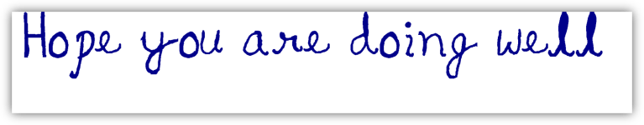
In the code above, I first imported the pywhatkit and OpenCV libraries in Python. Here pywhatkit is used to convert text to handwritten text and OpenCV is used to visualize the image in which we are writing handwritten text.

Summary
So this is how you can convert the text of a user’s input into handwritten text by using the Python programming language. I hope you liked this article on the task of converting text to handwritten text using Python. You can find some amazing Python programs and projects solved and explained with source code from here. Feel free to ask your valuable questions in the comments section below.

